Crypto Lab Assignment
Jacob Ellis

Part one
- Do the three distributions above depend significantly on the type of text?
- They depend on the amount format and structure of which the text is arranged
- The screen shots have been provided online submission

http://www.nytimes.com/2011/10/31/business/media/ad-companies-face-a-widening-talent-gap.html?ref=technology

Part two
- Determine how good is the match between frequency distributions for short texts and long texts of the same type. Summarize your observations.
After observing each of the Histogram, Digrams, and trigrams of short and longer files, they seem to be only slightly different. Even through the character amounts were significantly different the percentages were still almost identical.

Part three
- Screen shots submitted online
- The characteristics are fairly evenly distributed for all letters

Part Four
- Screen shots submitted online
- 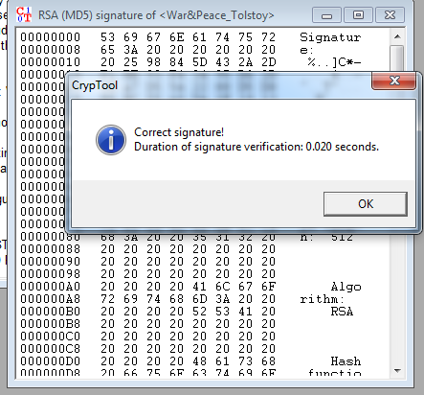

Part Five
- cyphertext 1 used Ciphertext only – Ceasar with the key ‘M’ , Ciphertext only – Vigenere with key of ‘N; , And Hill with using key of ‘B’

“Anna Pavlovna's drawing room was gradually filling. The highest
Petersburg society was assembled there: people differing widely in age
and character but alike in the social circle to which they belonged.
Prince Vasili's daughter, the beautiful Helene, came to take her father
to the ambassador's entertainment; she wore a ball dress and her badge
as maid of honor. The youthful little Princess Bolkonskaya, known as la
femme la plus seduisante de Petersbourg, was also there. She had been
married during the previous winter, and being pregnant did not go to
any large gatherings, but only to small receptions. Prince Vasili's son,
Hippolyte, had come with Mortemart, whom he introduced. The Abbe Morio
and many others had also come.”

